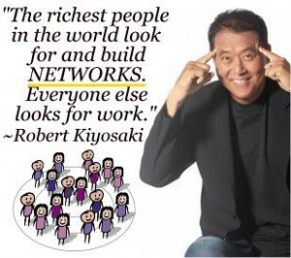

Thoughts about why

ISAGENIX chose NOT

to use a retail or

'commercial' business model

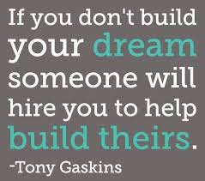Here are my views: The guy behind body trim is successful and he has some reasonable views on nutrition but as others have highlighted it is not perfect. I heard he turned over 90 million last year and I would imagine a large portion of the profit associated with that went into his pockets - something being commercial does not necessarily make it good as motivation for success often departs the original vision and becomes one that is driven by numbers i.e. company driven by profits, margins, ratios and statistics gives it all the wrong reasons to grow and be 'successful'. I personally prefer the motives of Isagenix get people healthy, share and help and change world health and for those with the skills and the inclination provide an income opportunity. One of the reasons John Anderson left the commercial sphere many years ago was due to his dis-satisfaction of having to be 'commercial' i.e. use substandard ingredients, use synthetics instead of naturals, cut back on quantity of ingredients. Commercial also typically means manufacture in production facilities that are cheaper and less dependable re quality. I love the fact that I know one of the drivers behind the formation of Isagenix was the Zero compromise to quality standard that John Anderson holds dear. This is not a standard that is often maintainable in a 'commercial' world. - **Matthew Ralph**

I believe that 'commercial' products can be purchased by anyone over the counter so majority of the sales come from people who are just trying everything, they are not the 'real buyers' in any market. They are not looking for support, for help, they don't usually have any long term goals. They just want a 'quick fix'. Isagenix is an exclusive high quality product that is manufactured from only the best sources globally. Isagenix produces 'results'. There is no comparison to this and I for one would not want a product like Isagenix to become a commercial product because if that happens than we lose the core and principles of what Isagenix is all about and that is to be 'clean, lean, healthy' and to help others do the same. We help people achieve real results that are long term. I have to agree with Matthew Ralph, being commercial means a cheaper product with cheaper quality sources which will make it less effective and run of the mill product. There are so many products on the market but none like ours. Stand your ground around quality and integrity but don't waste your time trying to convince someone, there are a lot more people out there who need to try our products. ~ **Rosalina Soto**

