

**Frustrated by Weight Fluctuations?**

**What the Number on the Scale Really Means**

The scale - *It's all numbers but you still can't count on it.*It has to be one of the all-time worst inventions passed off as a tool for monitoring progress that's actually responsible for causing more people to give up on their weight loss goals than actually help! Faced with the frustration of numbers that don't go down fast enough, don't budge at all, or seemingly worse, go up when you know you've been doing everything right, it's easy to become discouraged. So much weight is put into that number on the scale that it blinds people to the deeper truth that lies between the numbers; what that number on the scale really means. What it really means when it doesn't move or goes up for no seemingly explainable reason. Well the truth is there are some very good reasons behind why the scale reads what it does.

Fortunately the scale reading is *only a number*. Like all pieces of data, this number may or may not be an accurate reflection of whether or not you are losing fat. Let’s look at problems with over-relying on your scale weight and how we can better interpret this number.

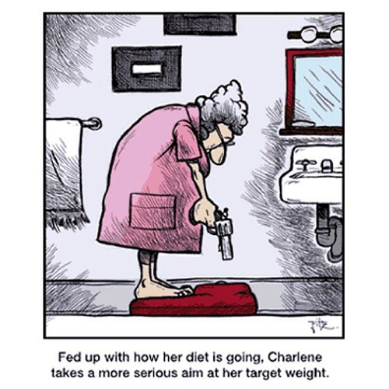**An "Ideal World" vs the "Real World"**

For some reason we've been misled into believing or we really want to believe that we live in an ideal world where weight has no room for variability. For example, in this ideal world, Ann has 150 lbs of lean mass and 50 lbs of fat mass. That means Ann weighs 200 lbs at 25 percent body fat. Now let’s transport Ann to the real world. The one where the scale can be a fickle pain in the you know where. How much does Ann really weigh? Ann would probably weigh somewhere between 196 and 208 lbs. Why the difference? One's "scale weight" can be broken down as follows:

**Scale Weight = True Weight + Weight Variance** (aka weight of those annoying little weight gremlins that mess with your body)

**True Weight:** The weight that you would be in our ideal world above (there are ways to get close to this).

**Weight Variance:**A value that adds or subtracts from your weight, given the conditions below.

Something interesting that I’ve seen from clients is that the upper and lower limits are asymmetrical. The upper limit of one’s scale weight is about +4% of his/her true weight (200lbs in Ann's example), whereas the lower limit seems to be about -2% of his/her true weight. Hence, why Ann’s scale weight is 196 to 208.

**Understanding Variations in Weight**

Here are a few things that factor into “weight variance:"

* **Glycogen stores.** This amount depends on your current consumption of carbohydrates. For every gram of carbohydrate that your body stores via glycogen, it also stores three grams of water. If you are carbohydrate-depleted, you will be at the lower end of your variance. Conversely, if you consume a lot of carbohydrates, you will be at the upper end of your variance.
* **Water retention/depletion from sodium.**If you suddenly consume more sodium than you are used to, you will likely retain water. Conversely, if you suddenly consume much less sodium, you will release water. The key words here are what your body is "used to" which does not necessarily mean you have to consume what would be considered a high amount of sodium. It's relative to what your body is used to. Your body adjusts to the new levels accordingly via the hormone aldosterone, so don’t think that you can keep this value low just by cutting sodium out from your diet. Sodium is NOT the enemy we've been misled to believe. For more about the importance of sodium please refer to this article: [http://www.fitday.com/fitness-articles/nutrition/healthy-eating/the-importance-of-salt-in-your-diet.html](http://l.facebook.com/l.php?u=http%3A%2F%2Fwww.fitday.com%2Ffitness-articles%2Fnutrition%2Fhealthy-eating%2Fthe-importance-of-salt-in-your-diet.html&h=qAQFwqeKn&s=1)
* **Cycle bloat.** Women will retain water during their cycle. How much varies significantly between different women and even between different cycles for the same woman. For this reason, although one can monitor weekly progress, it’s best for women to only make credible comparisons with weight (and other measurements) from month-to-month or over at least a 2 week period looking at measurements unaffected by their cycle for a more accurate perspective. EVERY MONTH with my own wife and many clients, I see firsthand how much a woman's cycle impacts her measurements. It becomes so predictable that I can see what's happening even before they do. Just remember, that whatever happens during that week is nothing but a temporary blip that shows up in the measurement radar. When staying on track, those measurements not only return to normal but reveal continued progress the following week.
* **Dehydration.** This obviously comes into play, but we’re going to assume that you're well-hydrated. So just drink all your water!

**Scale Weight Fluctuations**

Why does the scale seem so erratic when you are dieting? The foremost reason is that glycogen (the storage form of carbs in the muscles) is a much more volatile energy substrate than fat. That is, fat loss occurs slowly, while glycogen levels can swing wildly. Let’s see what happens at both ends of glycogen storage.

**The High End: Full Stores**  
This can be experienced in the form of a) temporary bloat from a **planned "cheat day"**, b) temporary but more significant bloat from **unplanned binge eating**, or c) the *natural and desirable* increase in muscle glycogen stores that occurs when coming off either a **cleanse day**or **lower carb day**as the muscles replenish themselves. What happens when people go on a binge? Typically they will retain a ton more glycogen afterwards and see a massive increase in the scale. This is only water weight. Too often, I’ll see people defeated because they “gained all of the weight back.” The same thing happens with cheat days but on a much smaller, more controllable scale (note: cheat days help prevent the body from plateauing and give the metabolism a natural boost). One thing that you rarely hear about water bloat is that it makes you look fatter than actual fat. Yes, that means that a person whose true weight is 190 lbs and bloats up to 195 lbs will look fatter than if his/her true weight were 197 lbs. Try this for yourself. When you are on a diet, take weekly pictures of yourself when you adhere to your nutrition plan. CONT>>>

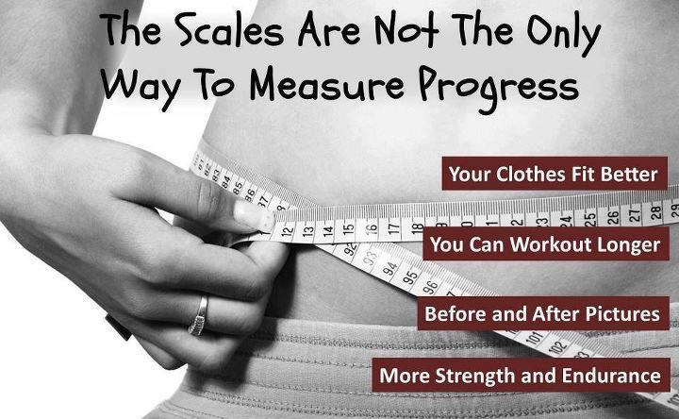After you’ve lost some weight, take pictures again after eating wildly for a day. Find the two pictures that match up with the same weight. You’ll notice that you will look fatter in your latter pictures, even if your true weight ls lower. If you find yourself gaining a ton of weight after a bad day of dieting, remember, this is only *temporary*. Your true weight hasn’t moved much; it’s still subject to the laws of thermodynamics. (Interesting true story: As a test, I know someone who once consumed 1,200 grams of carbohydrates in one day with only trace dietary fats. Research predicts that almost none of this turned into fat. The next day, he looked like the Michelin man and his “skin” felt hurt and bruised.)

**The Low End: Carbohydrate Depletion**  
Those who go on Paleo or ketogenic style diets usually cite the rapid loss of weight at the very start, as well as the rapid influx of weight when they cease their low-carb diet. This isn’t due to some magical powers from copying the diet of pre-historic man. Rather, this is due to the rapid depletion and replenishment of glycogen.

**Other Reasons:** Scale weight will often lag behind true weight loss as the body deals with many temporary internal shifts as it re-adjusts to a new set-point in its true weight or changes in body composition. It's also common to gain lean mass and/or increased glycogen capacity during a healthy change in diet or with the addition of exercise. For that reason, scale weight may remain the same even if fat loss is occurring.

**Interpreting the Scale**

The true secret to interpreting the scale is building a story. Most people use the scale as a final number, rather than piece together a story of how the body is changing using relevant pieces of data. The scale number alone is useless when you need to troubleshoot.

Instead, we can create a powerful story by pairing scale readings with the following data:

* **Girth measurements.** This is the most powerful piece of accompanying data. That’s because tape measurements are far more useful at determining overall direction of fat loss. Take measurements around the chest/upper back, waist, hips, and thighs. At the waist, take multiple measurements at the navel, two inches above, and two inches below. Compare with last week’s measurements and assign the measurement either -1, 0, or +1 if the new measurement decreases, stays the same, or increases respectively. Now add the numbers together to determine overall direction that fat loss/gain is occurring.
* **Strength as determined by PBs.** Assuming that you have reasonable programming for fat loss, personal bests in exercise reps and/or weights are a good indicator of measurable progress. If your strength is increasing, then you are likely increasing your body weight from lean body mass as well.
* **Bloat.** This tells you how much variance is going into your measurements. Be keen on noticing whether or not you are holding water in key parts. This will vary from person to person, but it will be areas that seem to swell up after a binge or cheat day.

Remember our hypothetical universe where scale weight is equal to “true” weight? We want to replicate this as much as possible. For this reason, you should not interpret measurements under variable circumstances or when bloat is high. Either wait for it to go away (if it’s caused by your menstrual cycle) or eat normally for a few days (if it’s from a binge or cheat day).

Follow your program as it was meant to be followed. Be coachable and be fully accountable for your actions. Don't try to solve all the unsolvable mysteries of the human body. Take the guesswork and frustration out of your measurements by putting your faith in the process and not the scale.

