Cleanse Options:

**Daily Cleansing**:

This is when you take 1-2 scoops of Cleanse for life Powder at morning or evening. The benefits are nutritional, providing great nutrients for the body's night time rejuvenation and provide very mild cleansing benefits.

This option is Ideal for athletes with tight training schedules or those with illness.

**1 Day Cleanse: 20%** [aka Single Cleanse]

This is considered a moderate cleanse and begins when you wake in the morning and ends the following morning. Follow your cleanse guide provided in your cleansing system. Your guide reads per day:

* 4 serves / 2 scoops of Cleanse for Life or [8 x 1 scoop if you’d prefer]
* 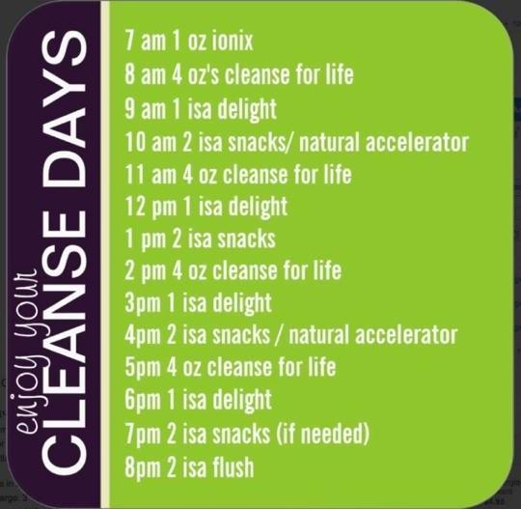Ionix
* Supplements [optional]
* 6 - 12 IsaSnacks
* 2-4 IsaDelight Chocs [optional extra]
* 2 e+Shots [optional extra]
* 1 serve Replenish [optional extra]
* 1 – 2 IsaFlush
* Herbal Teas [preferably organic]
* Sparkling mineral water [optional]
* Keep well hydrated

An 8th of an organic if needed for those with blood sugar challenges.

**2 Day Cleanse: 80%** [aka Double Cleanse]

This is considered a deep cleanse and begins when you wake in the morning and ends at 8am or when you arise on the morning the 3rd day (this is a 48 hour period or 2 full days).

**********************************************************************************************************

Founder and Formulator, John Anderson recommends all of the above options. He always shares that the magic happens in a full 2 Days of Cleanse, 5 Days of Shakes and Meals, 2 Days of Cleanse- providing the maximum results. There's nothing that replaces the 2-Day Cleanse.

There is a schedule that some recommend that suggests beginning your cleanse at night, cleansing through the following day, into day 2 and then on the night of day 2, break your cleanse with a shake. This method would be considered an 18 hour cleanse. This is acceptable however it is not to replace the deep 2 Day Cleanse mentioned above. Counting hours when you are sleeping technically does not count. True cleansing requires you to be up and awake, moving the body, consuming water and Cleanse for Life, hence this being dubbed and 18 hour cleanse.

No matter what system you use or what cleansing option listed above, you have flexibility. EG, some people can only cleanse for a 1/2 day while others are geared up for 2 Day Cleanses immediately.

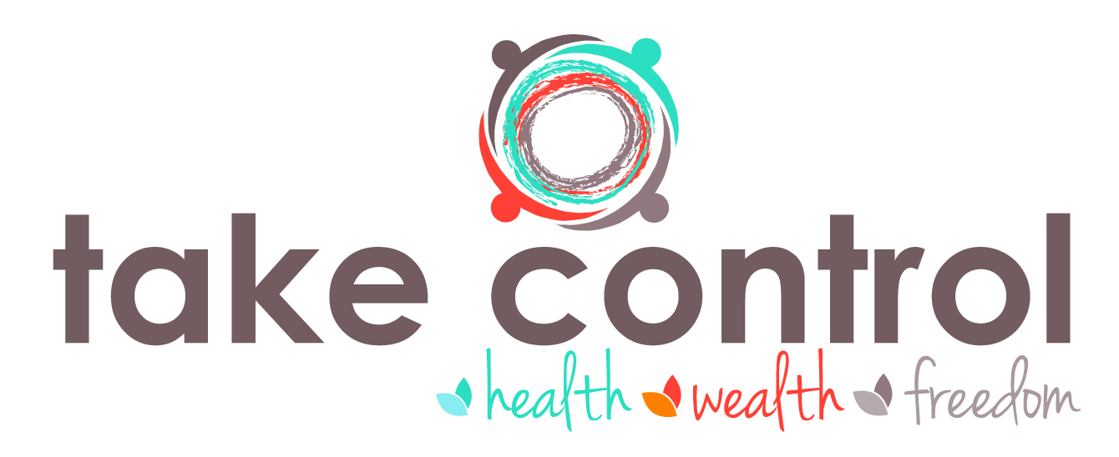Be flexible, listen to your body & know what’s right for you. Do deep cleansing when you're ready. Always remember, clean eating is great, but cleansing your body will rid it of the nasty toxins that harbour within sticky fat, promote lean and dense muscle growth & will help you function at your very best