A Farmers Story

Most people here won’t know that my hubby to be & I are (among else) beef producers & crop farmers. Nate has been farming for 25 years now and so therefore is considered an expert in beef production, cattle breeding programs, as well as crop production and soil fertility. From this expertise Nate has asked me to share some information, straight from the farmers mouth.

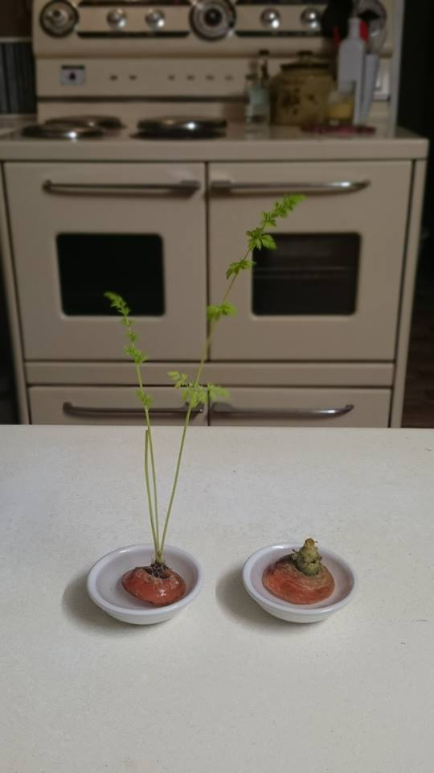"These days there is a lot of discussion around the importance of healthy nutrition and the two minds about nutritional cleansing and clean eating. I'm no expert in nutrition and am only sharing about what I do know, farming. I would like to take a moment to point out what most people are unaware of & unable to see in the foods that they have on their plate.  
  
The majority of today's farming and grazing land has now been intensively grazed and farmed for well over a century, most in plague and continuous efforts to feed the ever growing masses, the growing cattle population starving due to drought and the ever increasing pressure on farmers to run a successful business and live in today's economy. To do so, a farmer must produce a high amount of crop yield or cattle production. This results in over farming and over grazing. Farming land is pushed to its maximum and well beyond with planting, spraying, mowing/ heading, ploughing or zero tilling, spraying again and replanting whilst grazing land is over populated with cattle and being stripped bare of natural habitat to make way for more grazing land - further depriving the soils of its natural resource from debris & its ability to regenerate itself.   
  
*This has all led to heavily nutrient deficient soils.*   
Recently we conducted a test on soils on our own property that we have only just unearthed after further extending our farming land size. The tests from the soils that have not been farmed in over 100 years showed that the soil was high in organic carbon, high in nitrogen and it's pH level was 7 which is ideal. We then tested our farming soils which we due regularly before planting. These soils as predicted came back depleted, very low in nitrogen, sulphur and organic carbon and a very low CEC levels (this is the soils ability to release nutrients to the plant). Due to this we now need to use chemical fertilizers to manipulate the soils nutrient levels so that we are able to produce a crop. This may not be where the use of chemical stops. Depending on insects or weed, we may need to spray the crop later.   
  
We also are beef producers in tick infected country as many other producers are also. Due to this our cattle need to be sprayed by insecticide, something we only did today. Yes there is a withholding period, though does that mean that the beef is still the most nutrient it could be? We also inject for worming and vaccination, something that grows with the beast and again this is common practice among producers. Yes again there is a withholding period. To add into the mix, most cattle are being fed hay or grain grown from depleted soils that are chemically fertilized.   
  
We are beef producers who only eat organic beef... so what does that say to you?  
  
This is what the world of farming has been pushed to. We ourselves are trying to change our farming practices however finding new soils in a world that has just over farmed is very hard to do. From this I have now found the importance of organic produce and nutritional cleansing for myself and my family.   
  
As a farmer, I never would have considered this nutritional cleanse before, however now after knowing my own business and having experienced symptom's such as low energy, first hand that beneficial effects and increased energy from this program I am convinced of the benefits of it. 

To leave you with a little trivia please take a look at the picture:  
  
Both carrot tops were placed in a water dish on the same day 3 weeks ago. The carrot top with the shoot is from an organic carrot. The carrot top that is decaying is just a regular carrot. We think that this says it all.   
  
Please remember although we are professional farmers this is only our opinion.

**B. Harris**