**30 Day Program Outline**



Remember, regardless of whether you wish to

lose or gain weight

the first 30days are about

cleansing and rebalancing your body

so are essential for *everyone* to complete

**Option 1:**

Quick start, quick results incorporating 2 Day Deep Cleanse

**2 or more shake days** – remember on the Shake Day prior to a Cleanse Day dinner must be a shake:

**2 Cleanse Days**

**5 Shake Days**

**2 Cleanse Days**

*Shake Days for rest of month*

**Option 2:**

Standard 30 day Cleanse program incorporating 1 Day Deep Cleanse

**6 Shake Days**

**1 Cleanse Day**

**Repeat to end of month**

*Repeat month after month until goal weight achieved*

**Option 3**:

Daily Cleanse

**Every day is a Shake Day**

**Plus**

**Take 1 scoop of Cleanse for Life Powder to 120ml water on a daily basis**

*i.e. you are doing a gentle daily cleanse instead of an occasional deep cleanse*

*NB This option is only for high level athletes in season, diabetics or people on large amounts of medications.*

**Option 4**:

More weight to lose

**2 Shake Days**

**2 Cleanse Days**

**5 Shake Days**

**2 Cleanse Days**

**5 Shake days**

**2 Cleanse days**

**Continue until the end of the month**

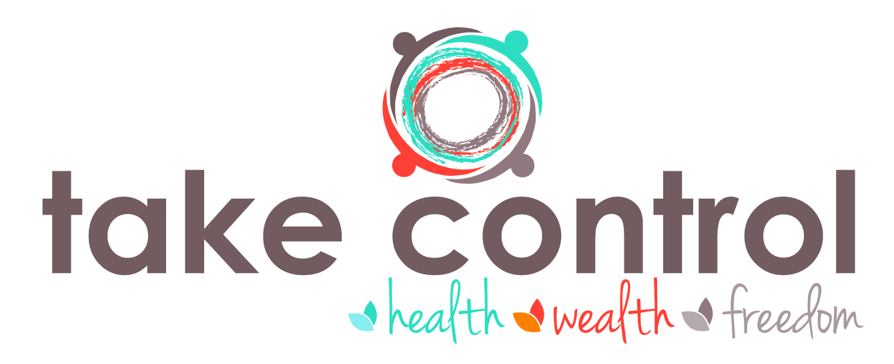*\*note you will need to order extra Cleanse for Life Powder for Option 4*